# Sprint 3 Report

Prepared by Lucas Myers, Adam Winebarger, Kyle Smigelski

## Intended Progress

At the close of Sprint 3, Team InnoValuation had anticipated having a 90% complete mobile application that meets all the requirements defined by our sponsor. The goals for this sprint were to complete the login functionality, capture user geolocation, enable sending of images to the database, and complete the questionnaire.

Lucas was most interested in database work, so he planned to enable the uploading of images and user geolocation to our Cloud Firestore database. He also planned to maintain the team’s Jira board like each of the prior sprints.

For Kyle, he was most interested in UI improvements for this sprint. He planned on designing and implementing visual changes to the questionnaire screen, as well as the home screen. He also planned on connecting camera functionality to the home screen.

## Progress to-date

As of Monday, March 11, 2024, the team has added picture taking and uploading, user geolocation capturing and uploading, a medical questionnaire and uploading user responses, user login, and a consistent UI. However, each feature has been implemented at its most basic fundamental level. There is still much tweaking, refining, and testing to do for each feature.

Lucas feels that the project has been going much more smoothly after the team’s conversation with Linda during Sprint 2. Once the requirements were finally set, the team was able to start making consistent progress. He feels like he is starting to get the hang of Flutter and is able to make meaningful changes to the codebase. He is concerned that the lack of team communication about flow and design choices will make for a poor or confusing user experience. Overall, he feels good about the status of the project and believes that the team will have no trouble fleshing out the current features and adding the remaining functionality.

For Kyle, this sprint more accurately reflected the team's expected work velocity. Compared to Sprint 2, the team had a much more concrete plan for features to implement in the application, building on the foundational work of the previous sprints. He feels that his design skills with Flutter are improving, demonstrated by the increased speed and quality of work during this sprint. Overall, Kyle is optimistic about the future sprints, and is confident in the team's ability to keep up their work and address any issues that may arise.

Adam wishes that he could have gotten a little bit more done himself on this sprint. However, between finding out about our project’s entrance in the *Reach Higher* event, a midterm rescheduled on short notice, and trying to get some more work done on his other capstones, he feels he did not contribute as much this time around as he has in the previous two sprints. He is, however, impressed at how quickly his two groupmates have picked up the more technical aspects of Flutter and often found that certain aspects of the project that he’d intended to work on were often already completed on other branches - which is a great problem to have. Despite the setbacks, Adam feels that we are in a pretty good place when it comes to the end-user side of things. But he does expect there to be a bit more to do in the next two sprints with the incorporation of a desktop application for doctors/administrators at the TST sites, making some changes to the back-end to separate initial photos from photos taken within the 48-72 hour window, and the incorporation of ROC’s ROC Enroll software into the project.

## Problems Encountered

The team has only encountered one issue this sprint. This issue is with the Reach Higher showcase. The team only found out about this three days before the poster was due and have not heard anything further. In fact, the team was signed up for this event without their knowledge, and only found out about this requirement this sprint. The team is still fully unaware of its responsibility in this showcase. This is a potential issue brought on by actors outside of the core team, and has the potential to impact work on this project. This information should have been brought to the team in Sprint 1.

Aside from the unexpected news regarding the Reach Higher showcase, the team has not encountered any issues with the sponsor’s requirements, the state of the project, or the work being done.

Lucas has no major concerns, and has not run into any problems during the work this sprint. He believes there is plenty of time for the last major features, which are the desktop application the clinician will use to report diagnoses, and making sure the user can only upload an image if it is within their 48-72 hour window. All other work should be minor tweaks.

Kyle also has no major concerns, although he expects some to possibly come up once the team begins working on the ROC Enroll implementation during sprint 4, considering the late addition of this major component. Now that the requirements have been set, he believes the remaining work can be completed within the time frame of this semester. He did not encounter any problems during sprint 3.

Adam had nothing major arise over the course of Sprint 3. He felt that things became a bit hectic with the news of the GVSU Reach Higher thing, and the need for a poster to be completed on top of everything else, with 4 days notice, during midterms week. But beyond that and the usual architecture-specific issues that occasionally arise when he pulls changes from the git repo, things actually went relatively smoothly the more he thinks about it. Adam thinks that this ROC Enroll incorporation is going to prove to be a bit of a curveball going forward and he does not believe at all that it will be as easy as it sounded during the group’s meeting with Rank One Computing. But he is sure that this team will manage.

## Projected Progress

By the close of Sprint 4 on Monday, March 24, 2024, the team anticipates that the mobile app will be 99% complete. They expect to have an idea of how to implement ROC Enroll into the project. Sprint 4 work will include tracking the user’s 48-72 hour post injection window, adding a help menu, adding more instructions throughout the app, adding push notifications, tagging images as the initial or follow up, and tying the user to their uploaded images.

Lucas’ velocity will remain the same as Sprint 3. By again completing 2 of the 6 sprint goals, he will be accomplishing a fair portion of the work. Along with this objective, he will assist the team with their work, maintain the Jira board, and be present for all communications. He will be working on tagging images and initial or follow up and tying the user to their uploaded images. This work will be touching the same code he worked on last sprint, so he will have a good idea of how to complete these tasks. He believes the team is on schedule for delivery.

Kyle expects his velocity during Sprint 4 to increase. As the team begins to add more major features, he expects to be able to work on more aspects of the UI and improve the user flow. He anticipates being involved in refining the tracking of the user's 48-72 hour post-injection window, implementing/enhancing the app's push notification system, and contributing to the development of the ROC Enroll feature. His focus will also be to improve the instructional content throughout the app for a smooth and intuitive experience. His ability to tackle multiple aspects of the UI and user flow improvements will hopefully impact the overall quality of the mobile app as the team nears completion.

Adam is expecting to add quite a few more things to sprint 4 as specifications for the ROC Enroll incorporation start to manifest. In addition, he is expecting to also outline some basic specifications for a desktop administrator application. These two things will certainly create an uptick in tickets for the group to work on but it is important to document these things as we move through this project. But for sprint 4, Adam’s main focus by order of precedence will be 1. Finish making changes to the back-end to incorporate separation of initial and window photos, as well as including attributes for relevant times such as when the initial TST injection was given and when a patient’s window begins and ends; 2. Perform code. As of writing, Adam feels that at least 75% of these goals will be achievable by the end of Sprint 4.

## Burndown Chart

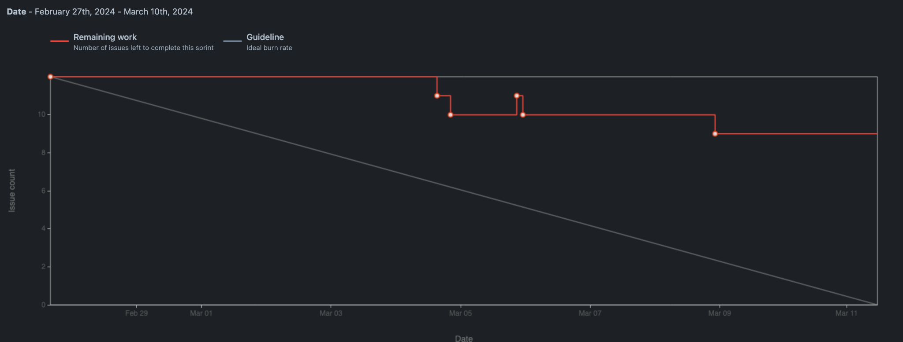

## Teamwork Reflections

Lucas feels that the team has found an optimal workflow now that the requirements have been defined. He feels that the team has been communicating less but outputting more, which is to be expected now that many design choices have been made and a direction has been set. He believes that each team member is giving an honest effort and is making consistent progress on their favorite areas of the project. He does feel that communication about progress could be improved, and he does not feel that the team has been following the peer review process outlined in the feasibility doc.

Kyle, looking back on the project's progress, agrees with Lucas on the need for better communication and a stronger focus on peer reviews. He plans to set up regular review sessions when convenient to improve the team's work quality. Kyle believes this will help catch issues earlier and make the team more effective. While he believes the team has put in good overall effort in communication, more transparency will help make the project more efficient and high-quality.

While Adam can see the point that the other team members are making about there being less communication over the course of this sprint, Adam thinks it was to be expected given the fact that week 1 of Sprint 3 was midterms for a lot of classes and week 2 was Spring Break. On his own end, Adam did let a few pull-requests go for a bit too long and it did lead to a few hours being spent primarily on resolving merge conflicts. He thinks that better communication will ultimately be beneficial but he also recognizes the unique circumstances that arose over the course of this sprint and thinks that communication going forward will probably more closely resemble what it was prior to sprint 3.

## Conclusion

In conclusion, the Sprint 3 Report for Team InnoValuation shows that the team has been able to make consistent progress now that the requirements are set. Now that each team member has been making their own changes, concerns about communication and peer review have been raised and will need to be addressed in Sprint 4. The team is confident that communication can be improved and that the project will be delivered on schedule. The team has shown a proven ability to pivot and reorganize, so the team is confident that all future challenges will be overcome. The team is satisfied with the distribution of work and is ready to continue development at a steady pace.